**Farmer assistant portal screenshots :**

**Home Page :**  This is the home page.

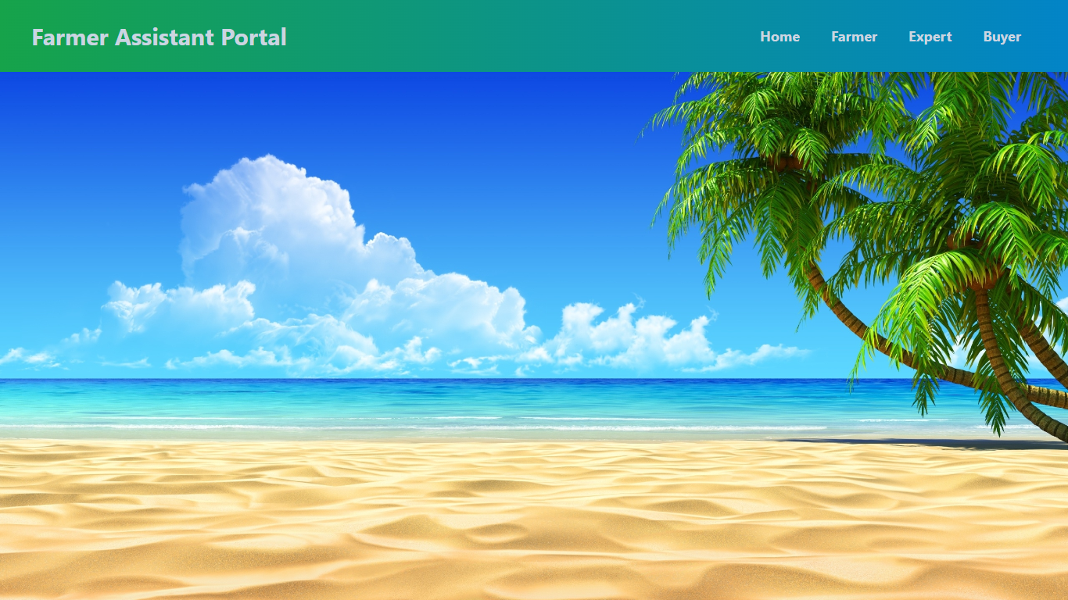

**Login Page :**  This is the login page .

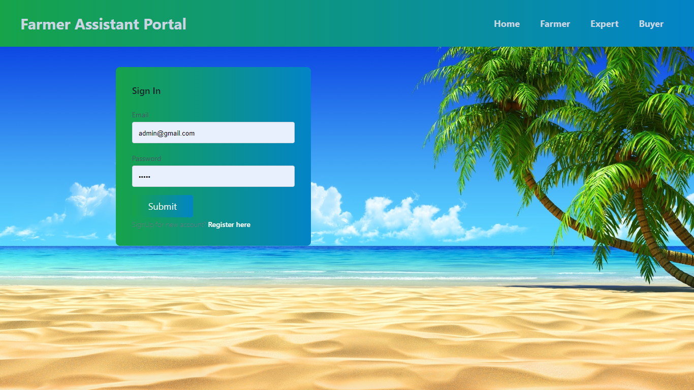

**Home Page :**  This is the admin home page.

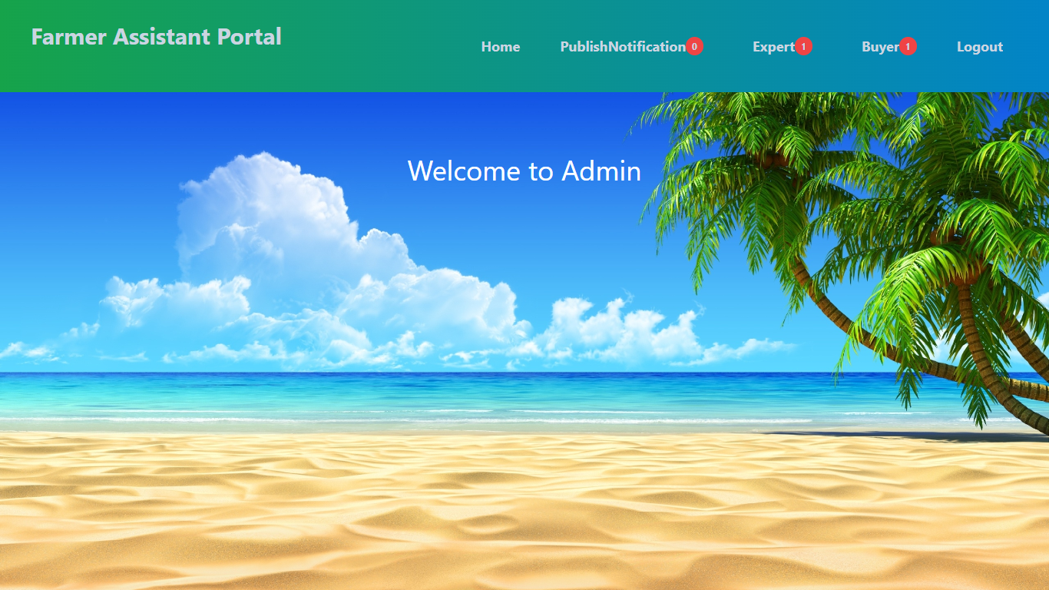

**Add notification :**  This is the page for add notification.

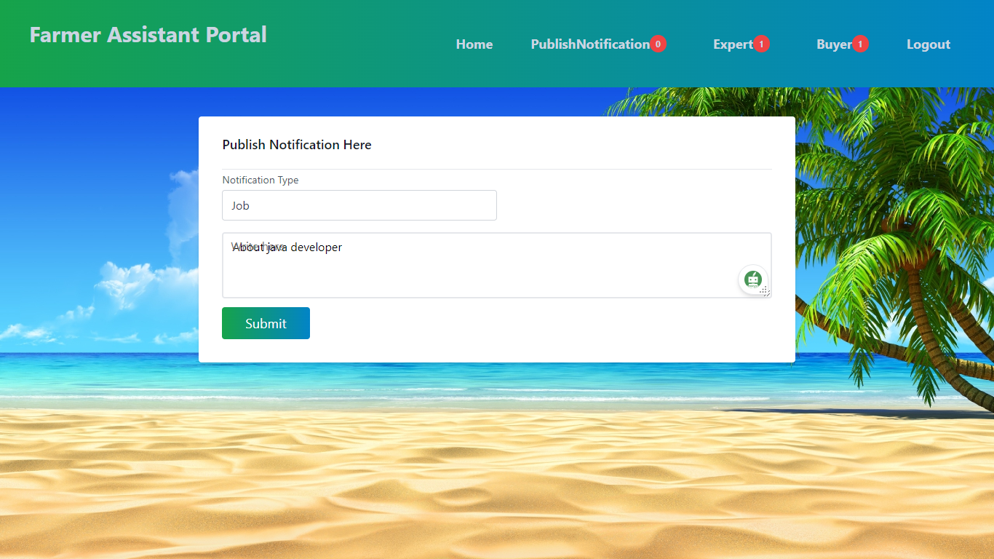

**CRUD on Experts:** Admin can manage experts.

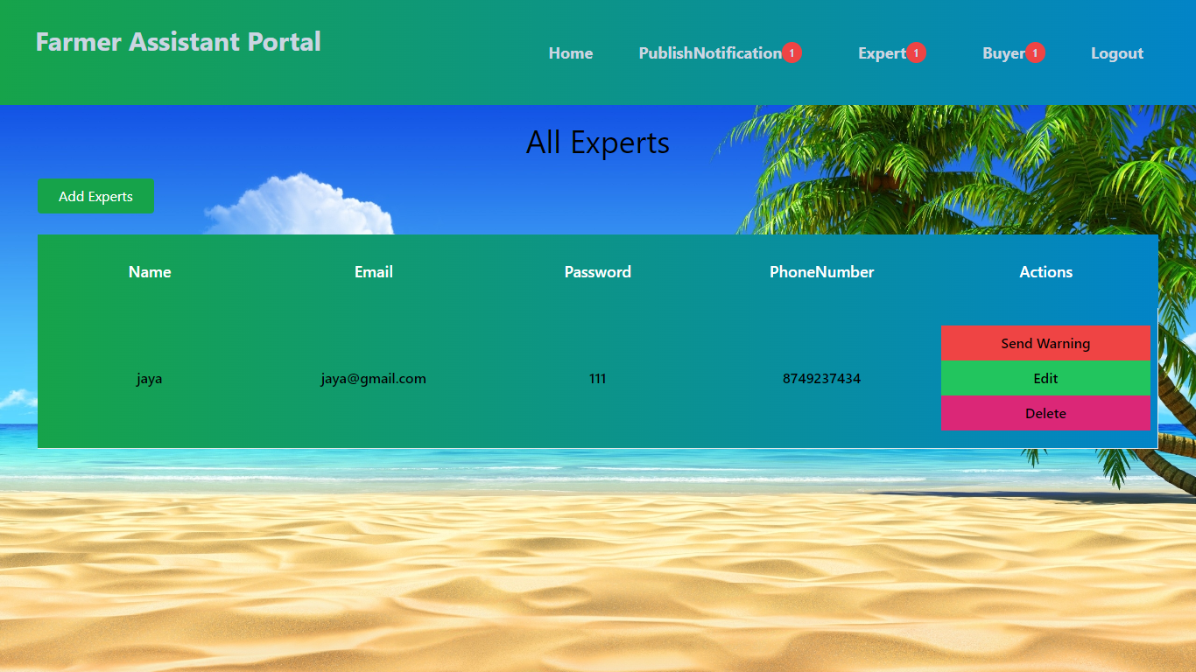

**Add warning:** Admin giving warning to expert.

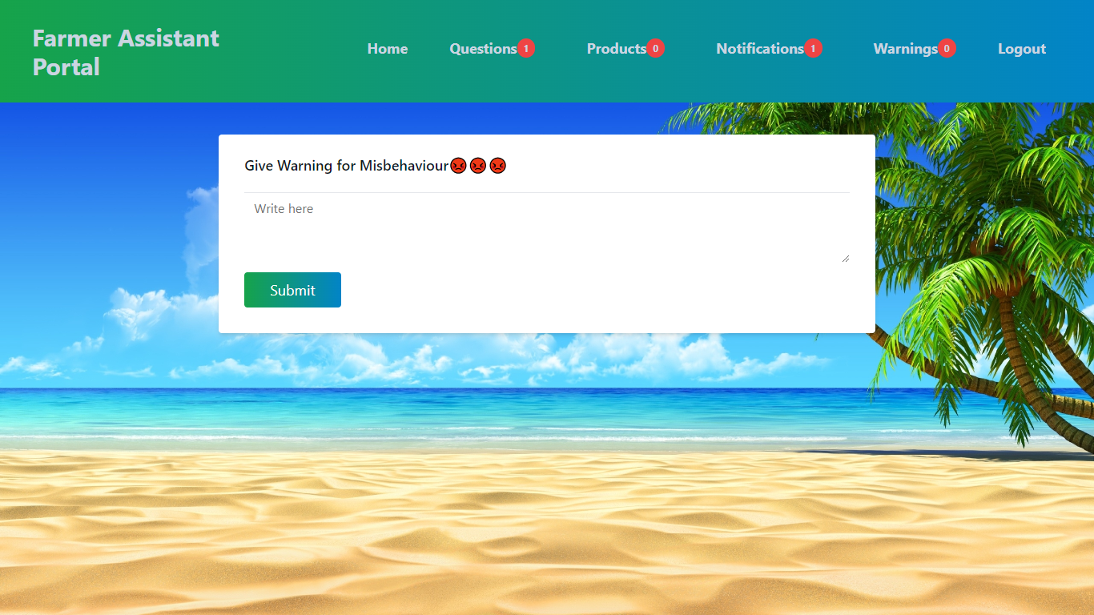

**View buyers:** Admin view all buyers.

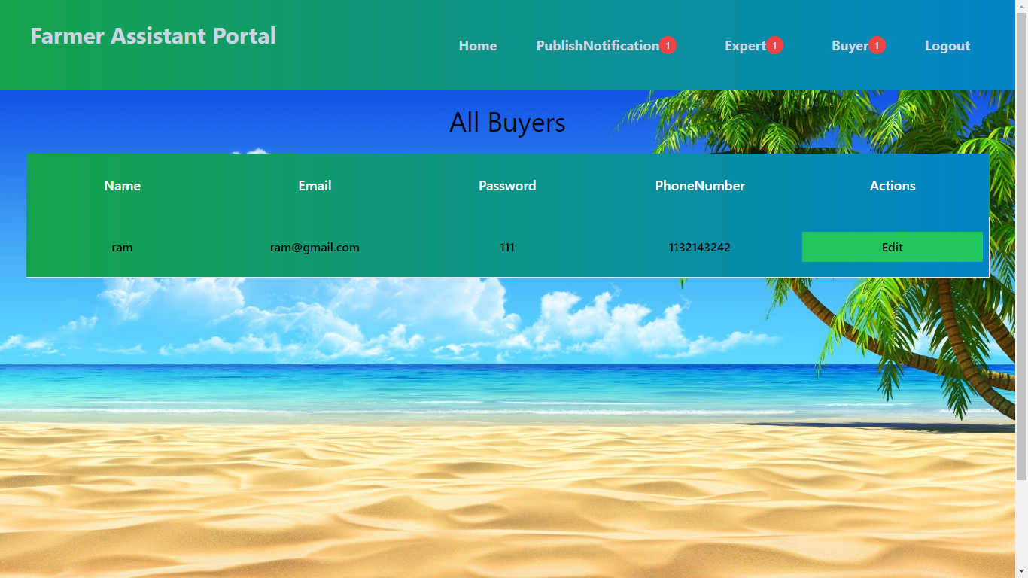

**Register page:** This is the register page.

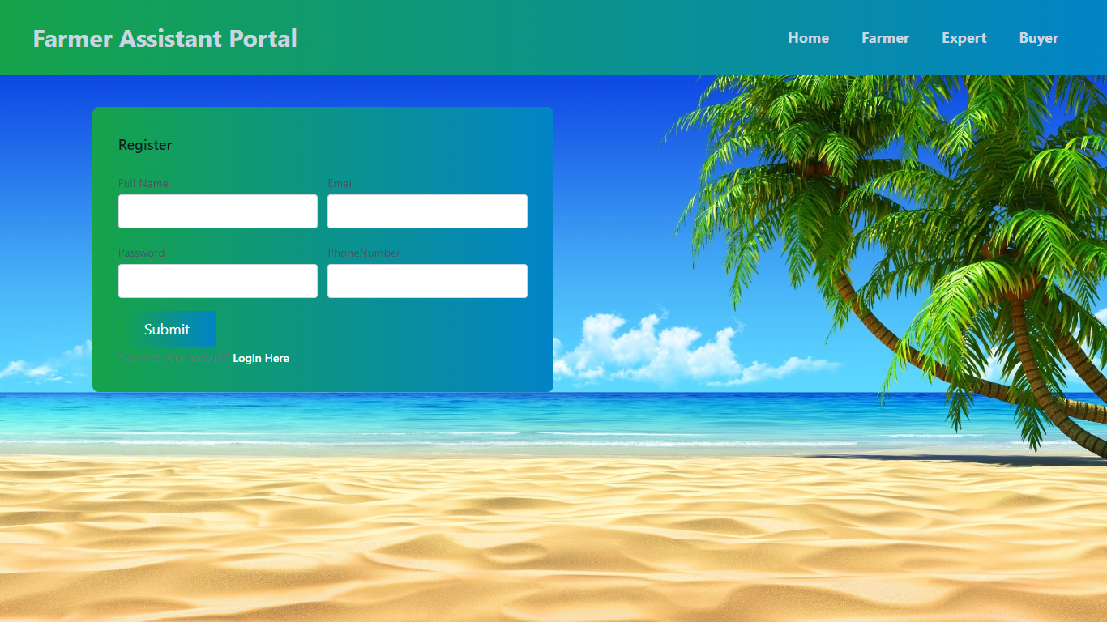

**View products:** Farmer can manage products.

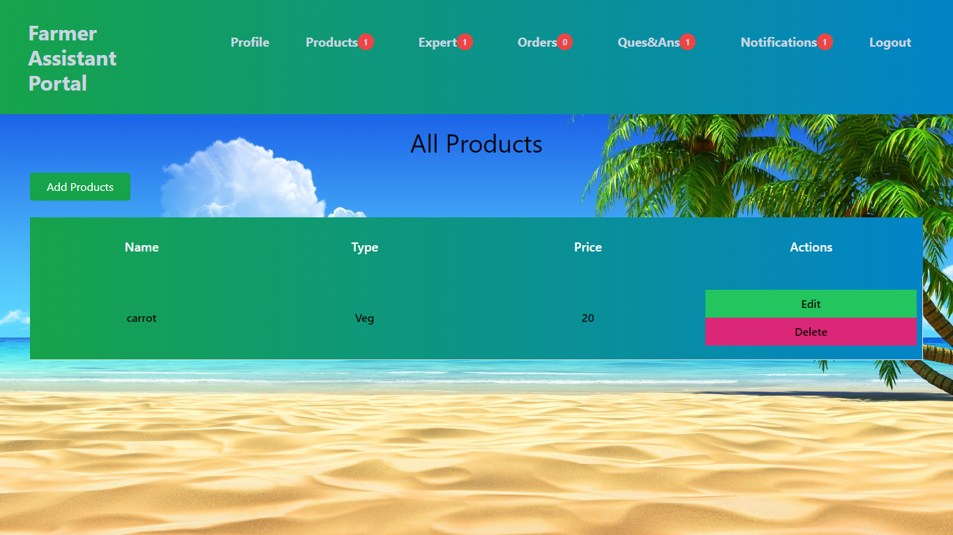

**View experts:** Farmer can view all experts

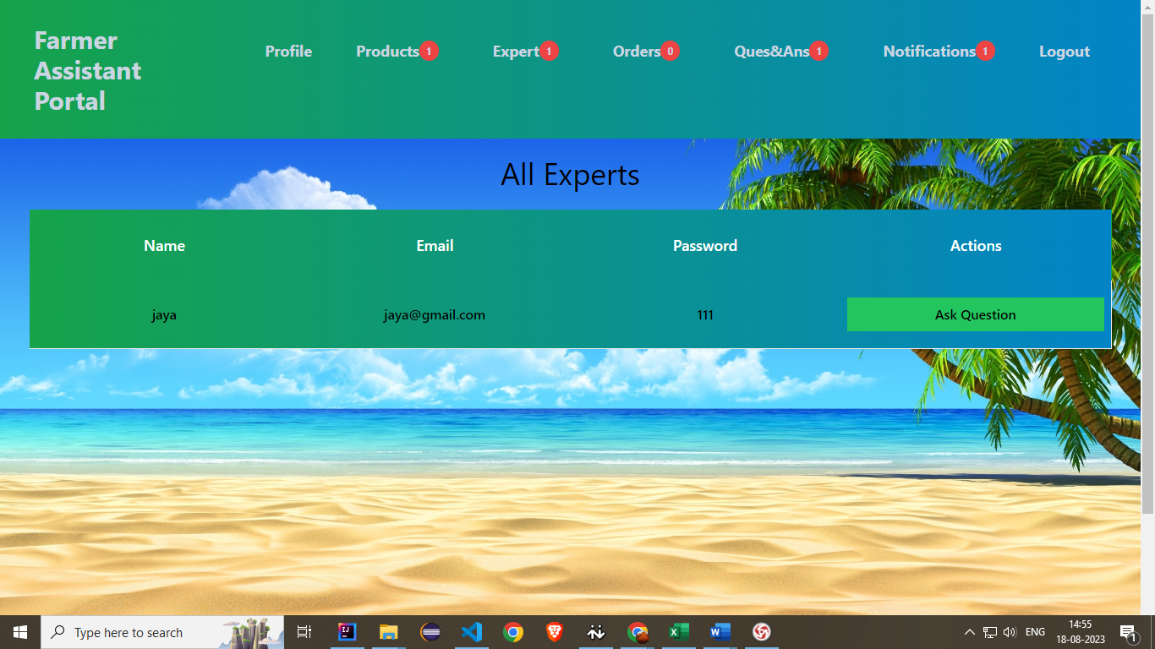

**View orders:** Farmer view all orders.

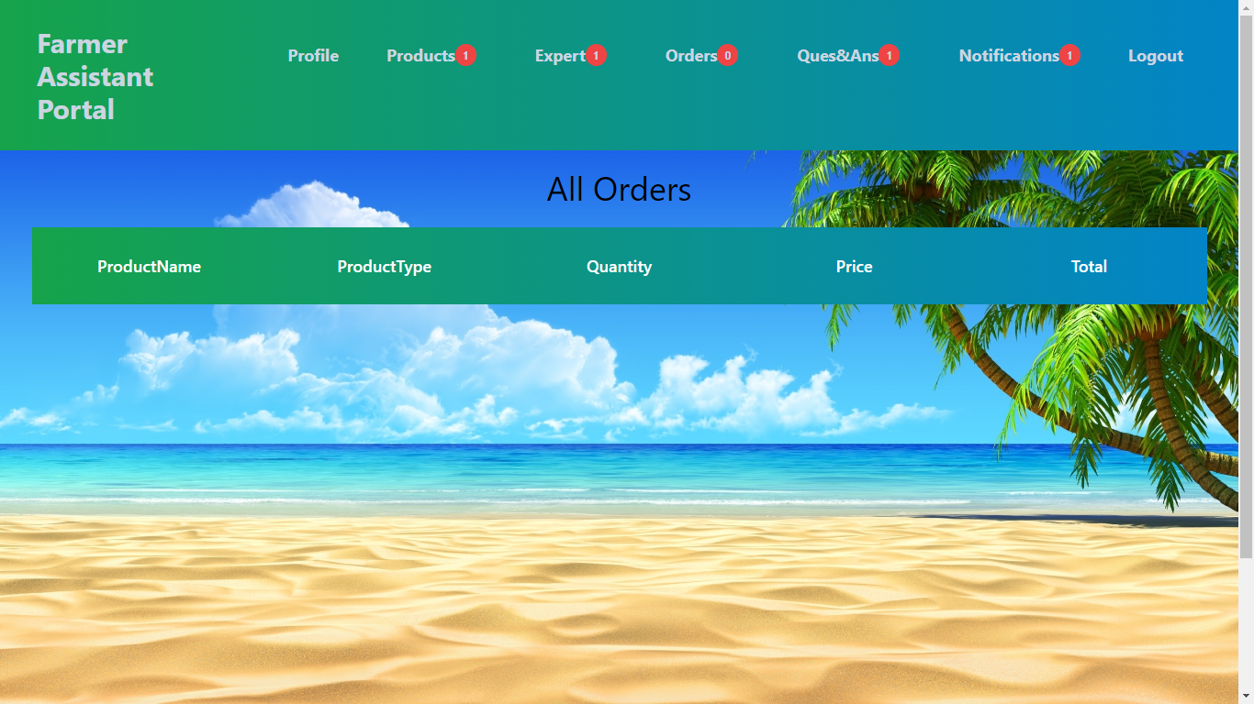

**View question& answers:** Farmer view all question and answers.

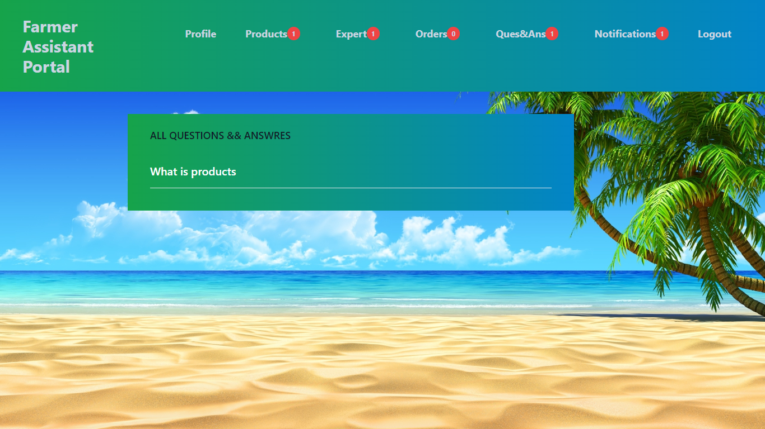

**View notifications:** Farmer view all notifications.

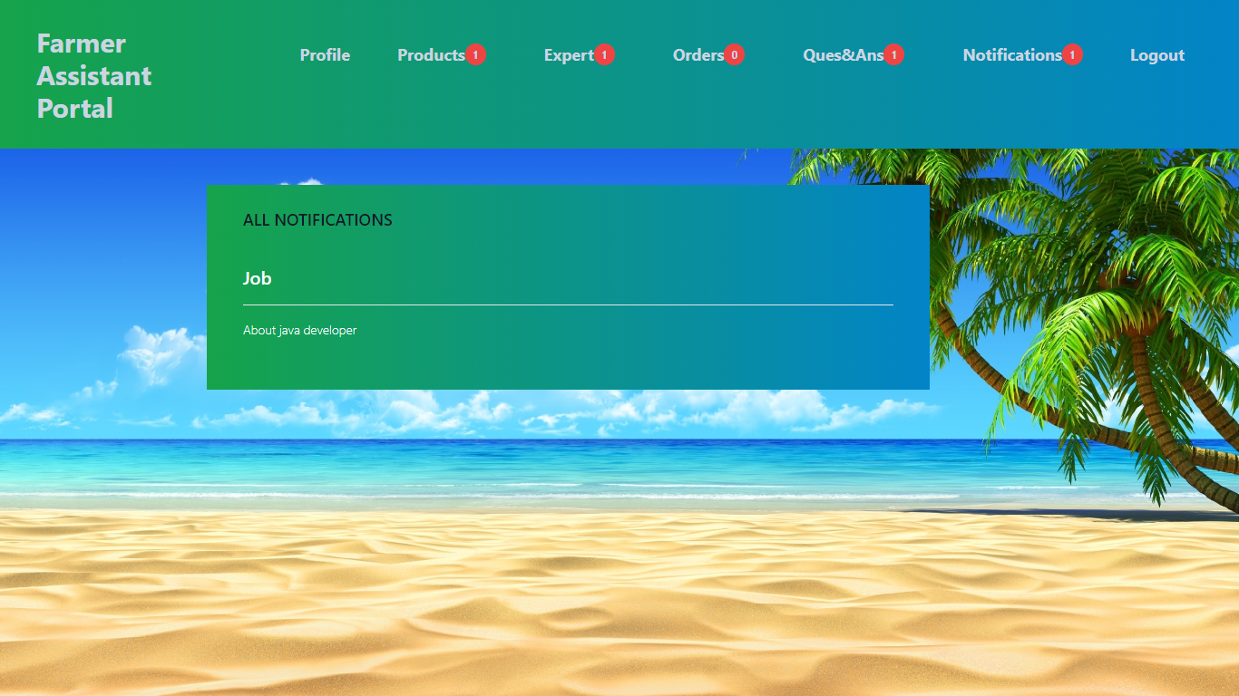

**Expert home page:** This is the expert home page.

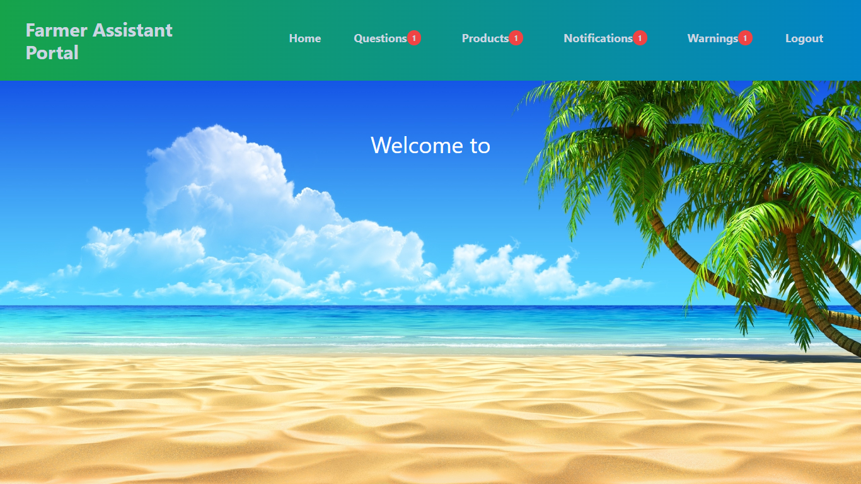

**View questions:** Expert view all questions and respond.

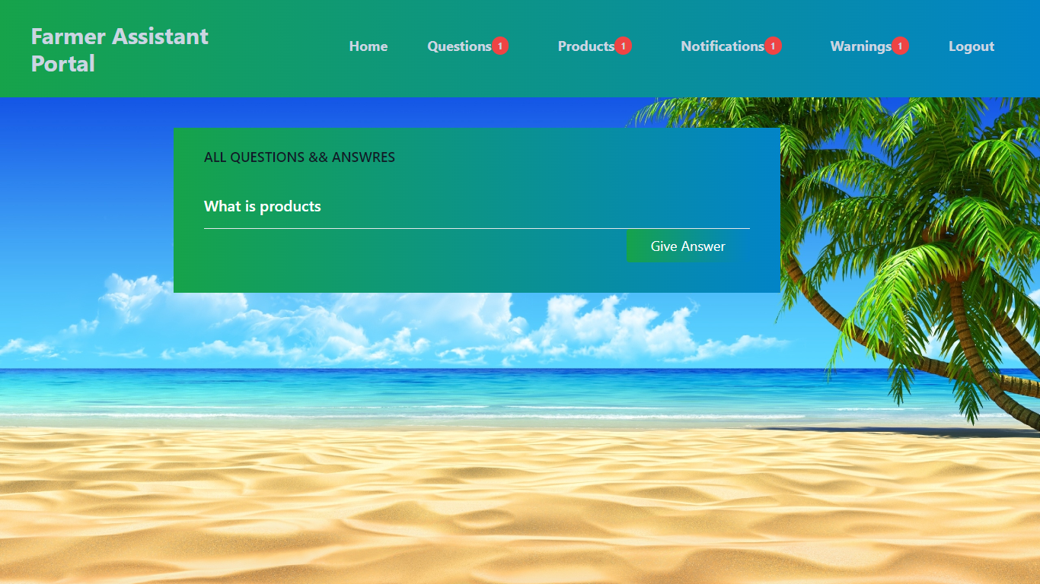

**View warnings:** Expert view all warnings.

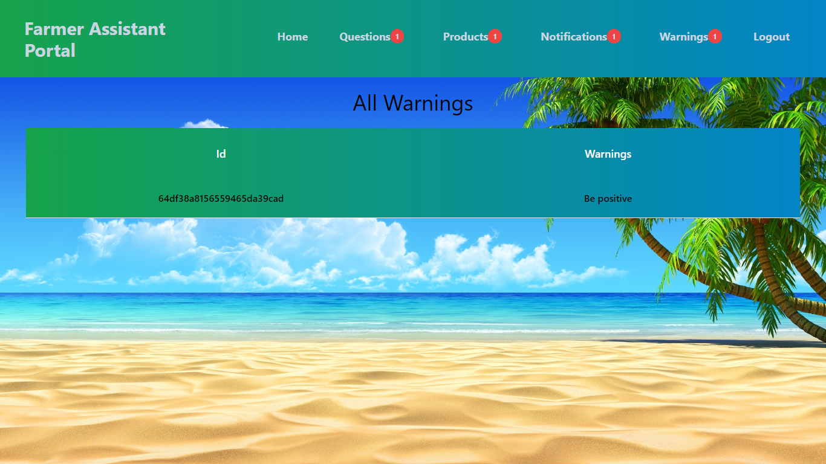

**Buyer home page:** This is the buyer home page.

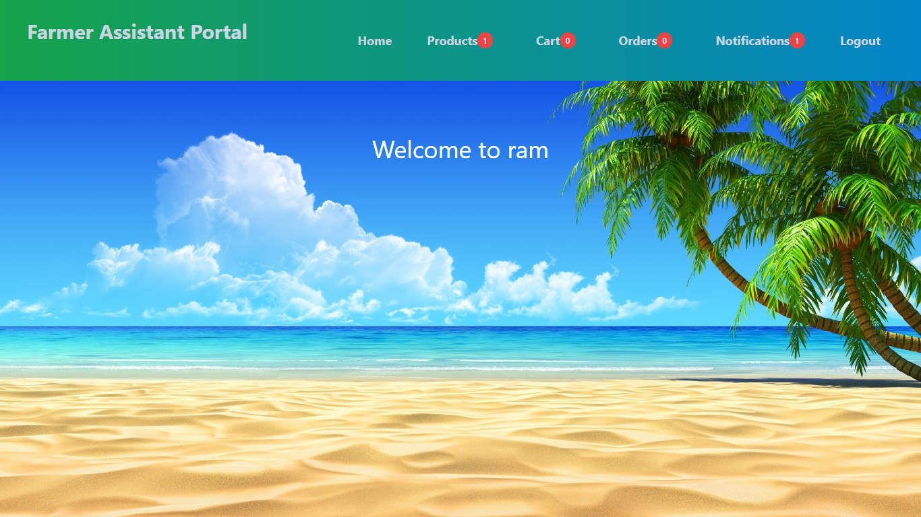

**View products:** Buyer can view all products and he can add to cart

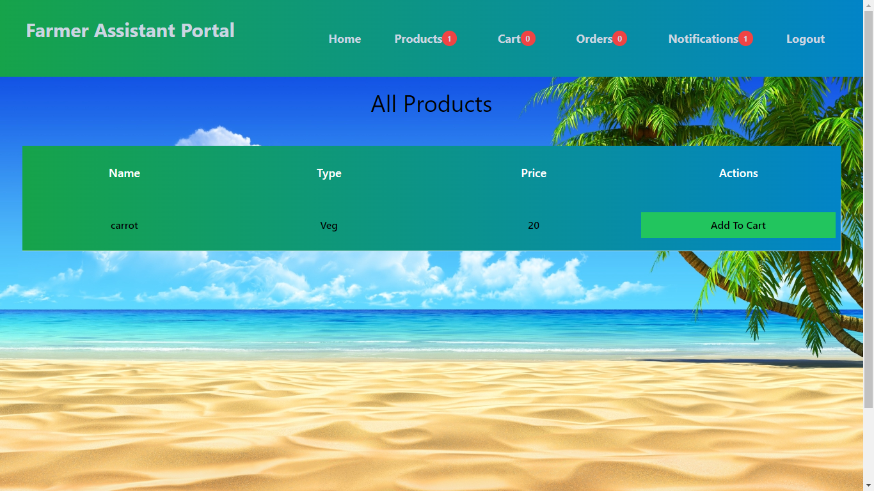

**View cart:** Buyer view his cart

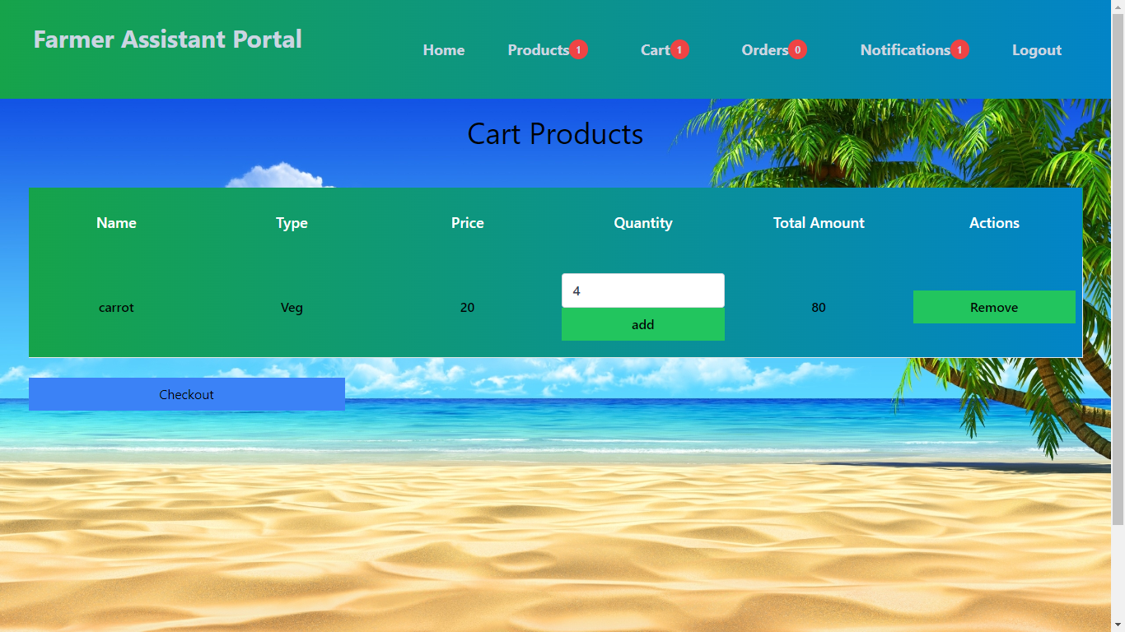

**View notifications:** Buyer can view all notifications

